|  |  |
| --- | --- |
| Umm Al-Qura University  Computer & Info. Systems College  Computer Science department | Advanced Programming  2nd Semester 2023-2024  Course Project |

Project Title

Grads Delight

Project Number #

Member 1: Fay Abdullah Althubaity ID:443002646

Member 2: Arwa Mohammed Asiri ID:443008129

Member 3: Rehab Khairallah Al-Mujairishi ID:443002513

Member 4: Aseel Ahmed Abdullatif ID:443016804

Advanced Programming Course

Instructor: Dr. Manal Alghamdi

2023- 2024

1- Project Title

Grads Delight.

2- Project Idea and Project Aims

The idea for Grads Delight application using JavaFX The application aims to provide users with a seamless and user-friendly experience for a system that provides managing graduation parties, it also aims to enhance our knowledge and skills using the javafx environment and using it to build functional interfaces.

3- Project Functionalities

* Navigating from the welcome page to two pages: packges and My orders
* Choosing the desired party package
* Choosing the extra services and decorations
* Calculating the total price of the order before confirming
* Observing the changes on the total price before confirming the order
* Storing order and customer information
* Generating a unique order number
* Displaying the order details from the receipt page
* Searching a specific order using the order number
* Input validation for efficiency

4- Project Design and Implementation

1. Graphical User Interface

6 interfaces have been designed which are:

Interfaces:

1)home page

welcome scene ,it will appear when the user open the app. it contain a simple description about the app idea and two buttons

1-My Order (to go on a search page to display your order)

2- package button (to display page of packages type).

2)packages

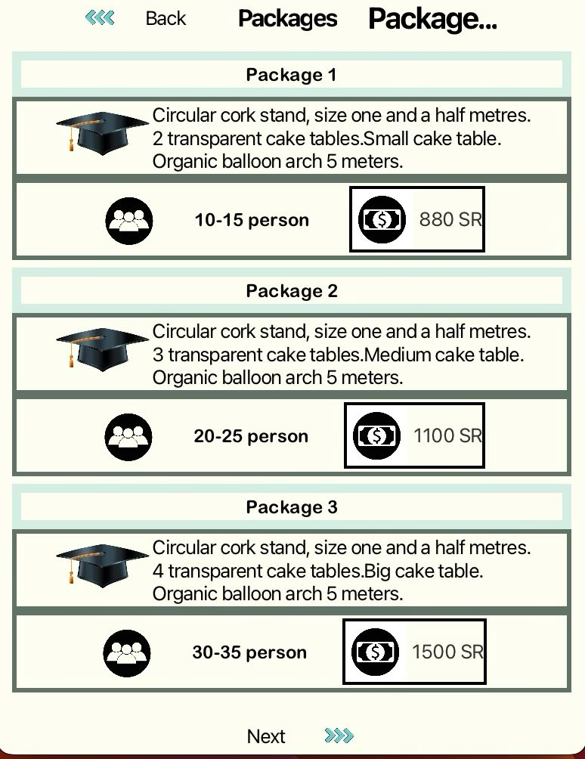

In this screen, three types of packages appear, each type has different characteristics and number of people. One package can be selected by pressing the right mouse button. When you choose the package, text appears at the top of the screen shows the type of package that was chosen, and there is a button to return to the home screen, and a button to go to the extra screen.

3)Extras

4)Customer information

Customer scene, the customer can sign up from this interface.Enter his phone number and name and choose his order appointment , then enter his credit card information (credit card name and number , the month and the year ,Creating sustainable value) . There is two buttons, The back button to back in the Extra scene, The Verify button it will verification all the customer information and then set the order and the customer information in the database.

5)order confirmation

Verify scene , this interface will show the order number when the order is completed. The back to home button to back in the welcome scene

6)My orders

My orders scene this scene let you enter your order number and your phon number,and then you will Press on the search button, it validate user input if it is fine it will display your order information (order number,phone number,name ,date,package type,price,person name).

if you Press on back to home button it will return you to welcome scene

Usage flow:

First the user will be welcomed to the application by the welcome page, this main page contains a short introduction and the user can navigate to two other pages using the buttons on the bottom of the screen, firs buttons transfers the scene to the packages page, the cart buttons transfers to the receipt page , the new user will head to the packages page that displays three main packages categorized by suitable number of people, the desired package can be selected by clicking on the number of people text and a message shows that this package is selected, the user can move to the next page using the "next" button, or back to the welcome page through the "back" button.

In the next page a number of additional services is displayed for the user to choose from, showing the total price at the bottom, if the user wants to proceed to the payment he should click "next" button, and "back" button to go back to the packages page.

The next page is confirming the order and entering personal and payment information, the user is required to enter phone number, name, date of order, and after that enter the card information, the "verify" button will cause all the entered information to be inserted in the database and an autogenerated order number will be displayed in for the user, the customer can go back to the main welcome page to create another order, or go check order details through the receipt page by entering the order number, then all related information will be retrieved from the database and displayed.

1. Event-Driven Programming

Home Page:

* SetOnAction sourse (package button (to display page of packages type).)-on welcome scene
* SetOnAction sourse -->My Order (to go on a search page to display your order) )-on welcome scene

Packages page:

In the packages screen, there are five buttons, three to choose packages, one to return to the Home screen, and one to go to the Extra screen.

The type of buttons is mouse event.

The Back button (setOnMouseEnterd): returns the user to the home screen.

The Extra button (setOnMouseEnterd): shows the user the extra screen.

The first button (setOnMouseClicked): when it is chosen from the user, this means that he chose the first package.

The second button (setOnMouseClicked): when it is chosen from the user, this means that he chose the second package.

The third button (setOnMouseClicked): when it is chosen from the user, this means that he chose the third package.

Extra page:

Customer information page:

Back button (setOnMouseClicked):return the user to the extra screen.

Verify button (setOnMouseClicked): Will verification all the customer information and set the order and customer phone number and customer name in the database.

Confirmation page:

Back to home button (setOnMouseClicked):return the user to the home screen.

My orders page:

* SetOnAction sourse (Back to home button)-on cart acene
* SetOnAction sourse (search button)-on cart acene

1. Java Database Programming

Write paragraph(s) that answers all of the following questions.

Explain the need of database in your application and how you utilized from each table you have created in your database.

The database in our application were needed to store the customer log in information, and order information including details and total price…etc, later on the user can search the orders using the order number which is stored in the database.

How many tables? What are the columns?

Two tables:

Customer table: name, PhoneNumber.

Order table: orderNumber, packageType, date, totalPrice.

Explain how you connect your object model to your relational model?.

Hibernate

POJO classes:

Customer class

Order class

Explain the relationship between your database and your GUI, i.e mention all the mappings between the columns and UI components.

* Log in interface:

Customer name -> TextField input

Customer phoneNumber -> TextField input

* My orders interface (search);

Order number -> input

Phone Number-> input

* To be retrieved and displayed:

Package type -> TextField

Date-> TextField

Price->TextField

1. Model-View Controller

No Model-View Controllers were used.

1. Extra
2. Animation was used after confirming the order, displayed as flowing circles representing fireworks to announce the success of inserting the data into the database and generating an order number.

5- The distribution of the work

In this section, mention the distribution of the work between the team. Be honest and feel free to show your tasks individually. Each member (if you want) can calculate the spent time in this project (days, hours or even minutes).

|  |  |  |
| --- | --- | --- |
| Member | Task(s) | Time Spent (optional) |
| 1-Fay Althubaity | Customer scene and verify scene, customer tapledatabase) |  |
| 2- Aseel Ahmed Abdullatif | welcome scene  cart acene  tapledatabase |  |
| 3- |  |  |
| 4- |  |  |
| 5- |  |  |

6- What we learnt

In this project we learnt how to build interfaces that are user-friendly and efficient along with how to implement connections between database workbench and the designed interfaces, this enhanced our knolwledg about database management and our ability to develop user-friendly applications.

The teamwork was the solid base to the success of our project, including distubution of work and scheduling daily meetings that last for hours to ensure our project met all outlined requirements, and to ensure out understanding of the code and its functionalities and the reasoning for our choices.

Generally, we are satisfied with the result of our work. We believe we have successfully met the project requirements, However, we believe that there is always room for improvement, and we aim to use our gained knowledge and experience to work on a larger scale projects in the future.

7- Project difficulties

We faced a number of difficulties working on this project such as: the difficulty setting the Hibernate configuration due to the variations in the IDE's versions., lack of time to meet our initial expectations.

8- Project Declaration

We confirm that the work of this project was solely undertaken by ourselves and that no help was provided from other sources as those allowed. As well as we confirm that we completely aware of the violation consequences of theacademic integrity.

Read and check the previous declaration.

List all your IDs

ID:443002646

ID:443008129

ID:443002513

ID:443016804